

Cookie Share Orders – Girl Links for Order Taking Sale councils

There are a number of orders through Digital Cookie as well as non-credit card sales that should be reconciled during the cookie season to give girls credit for cookie share sales. These sales add to total packages sold for rewards. To enter a Cookie Share sale for the girl, watch this video Virtual Cookie Share Order-Direct Sale or follow the steps below:

Navigate to Orders>Virtual Cookie Share
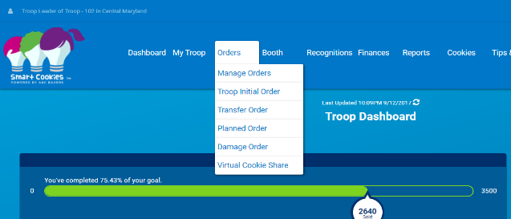
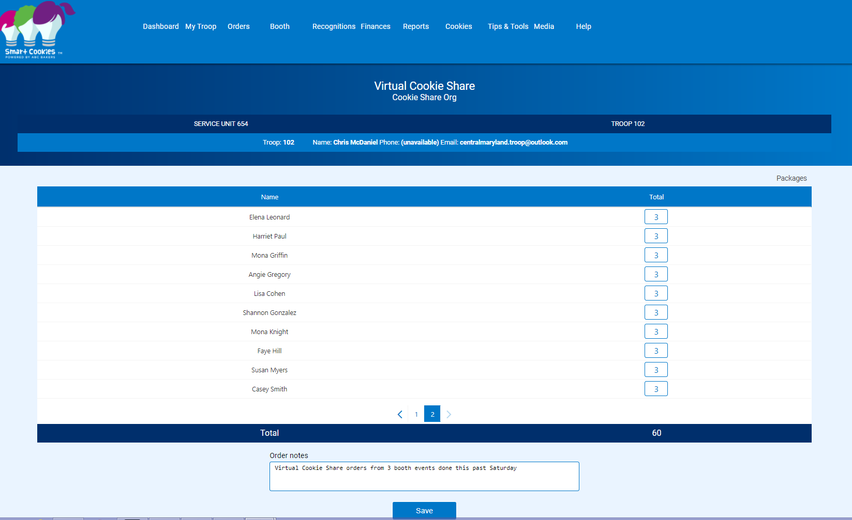

Enter the number of packages of Cookie Share cookies sold by each girl. The unit of measure is packages. Click Save.

Orders can be entered each time an order with Cookie Share packages is received or a total order can be entered at the end of the sale. If Cookie Share packages are not correctly entered in Smart Cookies, the total packages sold by a girl will not be correct which will affect girl rewards and girl financial reports.

Types of Girl Link Orders with Cookie Share and Actions

Locating Cookie Share Orders and Reporting

To easily locate Girl Delivery orders with Cookie Share sales, complete the following steps:

- Run the NEW Pending Manual Cookie Share Report for your troop.

- Review the line for each girl. The total number of Cookie Share from Girl Delivery will display as well as the number of CS packages NOT including in the initial order.
- A negative balance indicates additional Cookie Share packages need to be entered in Smart Cookies as Virtual Cookie Share for the girl. In this example, Ave has 5 total packages and those 5 were NOT on the initial order. No orders have been manually entered so the balance the volunteer needs to enter 5 packages.
- Two girls (Caroline and Selene) have a positive balance of Cookie Share orders. These orders represent orders paid outside of Digital Cookie (cash/check). Verify that cash payments have been posted for these orders or check to ensure you have not assigned too many CS to those girls.
- Noelle has 25 total CS packages paid in Digital Cookie for Girl Delivery. 15 were NOT on her initial order. No orders have been manually entered so the balance the volunteer needs to enter is 15 CS packages.
- Katherine has 3 total CS orders. All were entered in her initial order so she has credit for all Girl Delivery Cookie Share and her CC payments and CS packages are balanced. No action needed by the volunteer.
- The Total Cookie Share Manually Entered column only displays Virtual Cookie Share orders entered manually any the volunteer for the girl in the Orders tab – it will not include any Booth or Direct Ship CS packages assigned to a girl.
- To see all cookie share orders, volunteers can also run the Girl Cookie Order Detail Report.

Promising Practice: It is a good idea to review the reports often during the sale to ensure that all orders are up to date during the sale. Totals from Smart Cookies will display on the Girl Dashboard in Digital Cookie and if cookie share packages are not up to date, this can cause questions from caregivers regarding total balances due.

