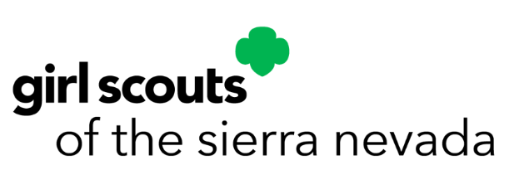

Volunteer Recognition FAQs

2022-2023

- Why are there adult recognition awards?
Girl Scouts of the Sierra Nevada is privileged to partner with a dedicated group of volunteers who deliver programs and services to girls every day. The adult recognition awards honor volunteers' contributions and years of service to Girl Scouting. Volunteers do not give of their time and talent just to receive recognition. They come to Girl Scouts to work with girls, learn and grow themselves, make friends, and give to their community. Honoring our outstanding volunteers is just one way GSSN shows volunteers how much they are appreciated.
- How often are awards presented?
Formal awards are presented each spring at the Volunteer Recognition event.

- What is the Volunteer Recognitions Task Force?
The Volunteer Recognitions Task Force consists of four to six Girl Scout volunteers and girl members. The group meets to review all nominations, submit their recommendations to the Board of Directors, and assist in the planning of the Volunteer Recognition event. The Task Force is accepting new members; interested volunteers – or Girl Scout Seniors or Ambassadors - can contact our team at girlscouts@gssn.org.
- Is there a prerequisite for the awards or an order in which awards must be received?
Candidates must have received the Thanks Badge before qualifying for the Thanks Badge II. All other awards are not given in any predetermined order.
- How do I nominate someone for an award?
You will need to complete the appropriate Nomination and Letter(s) of Endorsement forms. These forms can be submitted online at http://bit.do/gssnvols. Please remember to clearly and specifically state the candidate’s personal achievements and how they meet the criteria for this particular award.
- Who can nominate? Can staff or parents nominate volunteers for an award?
Anyone who has knowledge of the service performed may nominate someone for an award. This includes parents, community members, volunteers, and staff. The same requirements for the nomination process exist, no matter who does the nominating.
- Can staff be nominated for awards?
No. These awards are for volunteer service of adult members of Girl Scouts of the USA. If you would like to recognize a staff member, a letter to their supervisor or the CEO is always appreciated.

- When do I need to turn in the nomination, and who gets it?
All award nominations are due to GSSN by March 1, 2023. This gives the committee time to review the nominations, receive Board approval and order the appropriate number of awards.

- What should the Letter of Endorsement say?
Be sure to share exactly what the volunteer has done, why their actions are outstanding, and how their efforts meet the criteria of the award. Remember that this may be the reviewer’s only knowledge of the service and the nominee. Give relevant details that support the specific award being considered.
- How do I know what my nominee has received in the past?
A list of recent past awardees is available at http://bit.do/gssnvols. You may also ask your service unit leadership team, or contact GSSN at girlscoutshelp@gssn.org or 775-322-0642.

- What is the difference between the Numeral Guard and Years of Service?
The Numeral Guard represents the number of years a person has been a member of the Girl Scout organization, including years as a girl member. The Years of Service Award is given for the number of years of active service as a registered adult volunteer. Both awards are presented in five-year increments.

- If I have been a volunteer for 38 years, am I eligible to receive the 35 Year Pin or the 40 Year Pin?
You would be eligible for the 35 Years of Service Pin this year. When you reach 40 years, you would receive the 40 Year Pin.

- I'm not sure if a volunteer should receive the Appreciation Pin or the Honor Pin. What is the difference?
The Appreciation Pin is awarded for outstanding service delivered in a single service unit or program audience. The Honor Pin is awarded for outstanding service that impacts two or more service units or program audiences.
- I have other questions, who should I ask?
You may ask your service unit leadership team, or contact GSSN at girlscoutshelp@gssn.org or 775-322-0642.

